Annex I: Thrust/Pressure peaks observed in motor tests

There have been found two types of Thrust/pressure peaks:
Type I: In the thrust increasing part of the curve, before the máximum. Observing the videos, It is considered to be due to nozzle blocking because ignitor paper exhaust.
Type II: In the thrust decreasing part of the curve, after the máximum. It is guessed it is due to inhibitor exhausting.
It is shown in the following table and pictures D60-1 failure report_questions_annex I several tests and peaks examples:
Test | Propellant | Outer grain diam. (mm) | Nozzle Diameter (mm) | Grain Length (mm) | Core hole Diam. (mm) | Grain mean Density (g/dm3) | Rate (real/ideal) | Propellant batch | motor wall thickness (mm) | Case internal Diam. (mm) | Propellant weight (g) | motor weight without propellant (g) | motor length (mm) | Grain inhibition | Motor case material | Ignition
AC-D60_3S_27-05-20 | KDX (65-35) | 56,92 | 19 | 70,71+68,5+75,99 | 16 | 1671,1 | 88,9% | 22/05/20;22/05/20;23/05/20 | 1,5 | 60,5 | 842,2 | 2106,3 | Total length: 550  Combust chamber: 483 | 3 board layers | Stainless Steel | Electrical
AC-D60_7S_26-12-18 | KDX (65-35) | 57,37 | 19 | 66,21+67,30+69,54+64,72+72,71+66,09+63,31 | 16 | 1672,1 | 89,0% | 23/12/18;22/12/18;22/12/18;20/12/18;15/12/18;20/12/18;15/12/18 | 1,5 | 60,5 | 1873,5 | 2106,3 | Total length: 550  Combust chamber: 483 |  | Stainless Steel | Electrical
AC-D60_5S_07-02-16 | KDX (65-35) | 57,27 | 19 | 69,6+70,6+73+73,5+75,7 | 16 | 1675,6 | 89,2% | 4/02/16_L1; 30/01/16_L1; 31/01/16_L1; 4/02/16_L1;  31/01/16_L1 | 1,5 | 60,5 | 1443,0 | 2106,3 | Total length: 550  Combust chamber: 483 | 3 board layers plus liner (platic ply 0,3 mm) covering internal chamber and not glued to the grains | Stainless Steel | Electrical
AC-D60_4S_25-12-15 | KDX (65-35) | 57,4 | 19 | 70,90+78,35+75,90+67,20 | 16 | 1671,4 | 89,0% | 22/12/15_L1; 22/12/15_L1; 21/12/15_L1; 21/12/15_L1 | 1,5 | 60,5 | 1164,6 | 2106,3 | Total length: 550  Combust chamber: 483 | 3 board layers plus liner (platic ply 0,3 mm) covering internal chamber and not glued to the grains | Stainless Steel | Electrical

Test_3S_27-05-20
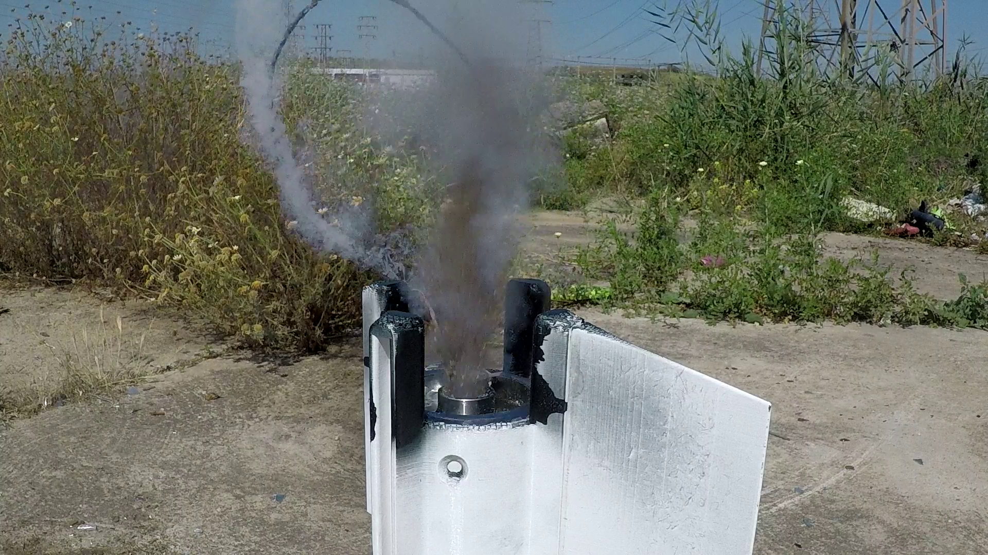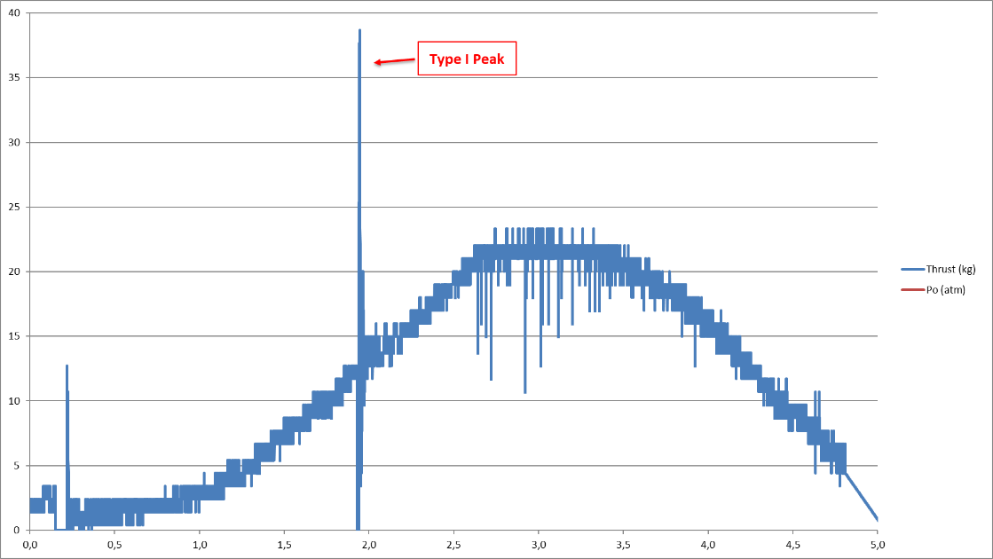

Test_7S_26-12-18
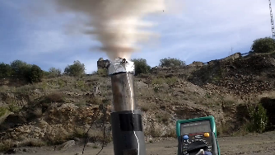
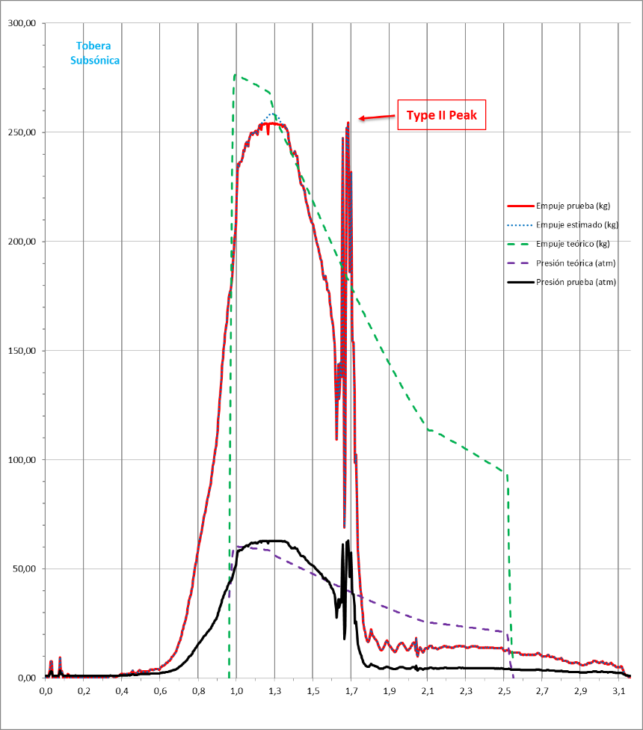

Test_5S_07-02-16
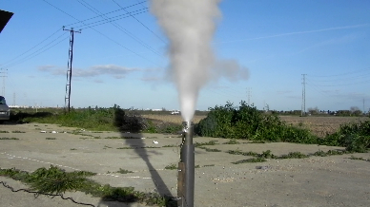
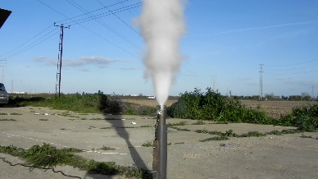
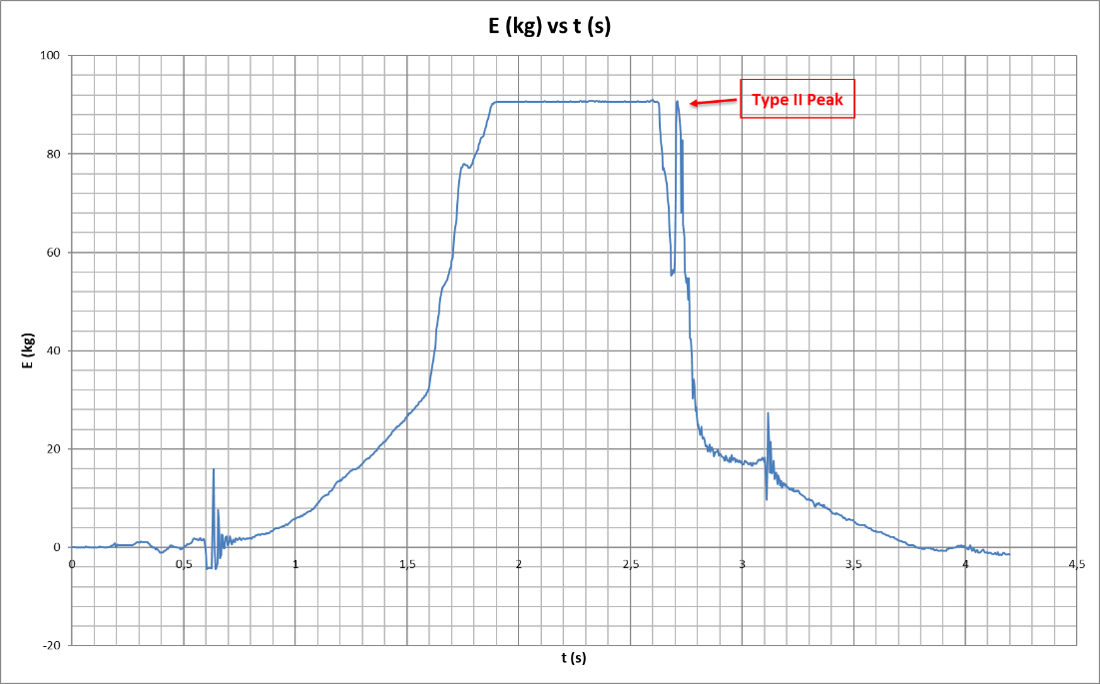
Test_4S_25-12-15
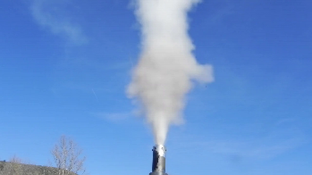
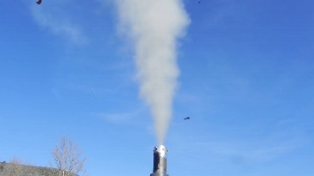
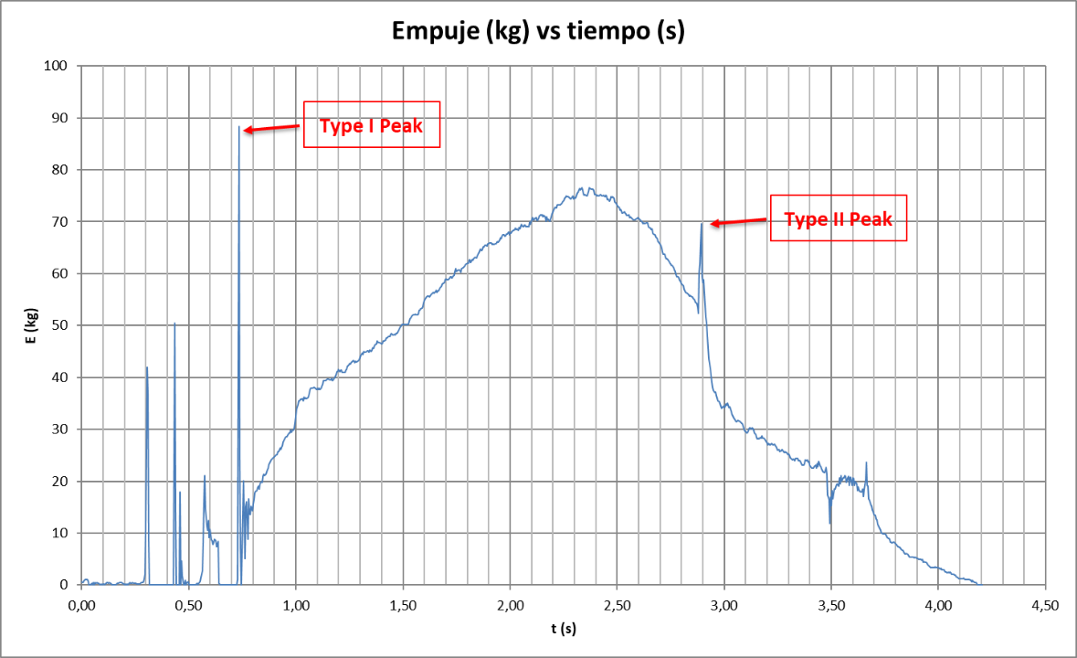
In the second picture it can be seen the red colour cardboard inhibitor pieces flying around after type II peak

