OPERATION MANUAL OF THE EDISON SIMULATOR
(Engine Differential Integration Solver Over Numerical)

Introduction
EDISON simulator has an interface created with app designer of the Matlab.
The file that has to be executed is “EDISON_v3.mlapp” and needs the following files to run:
- EDISON_UI.m
- datos_del_propulsante.m
- ayn.m
- r_burn.m
- empuje_atenea_UI.m
- empuje_sutton_UI.m
- EDISON_Inputs-Outputs.xlsx
The simulator can run through Matlab with a.m. files or through the executable version (.exe) that is installed in every computer and does not need Matlab to work.
EDISON includes two different algorithms to calculate the performances: ATENEA y SUTTON.
EDISON calculates the R_{g}, γ and T₀ of the mix of the different gases of the propellants. Up to now it is calculated with the initial mass of the grains and does not consider the different mass of the grains due to the different burning rates of the propellants.
The calculation of the chamber pressure P0 is done through the continuity equation. See “Procedimiento y algoritmo de cálculo.docx”
Both versions present the following interface:
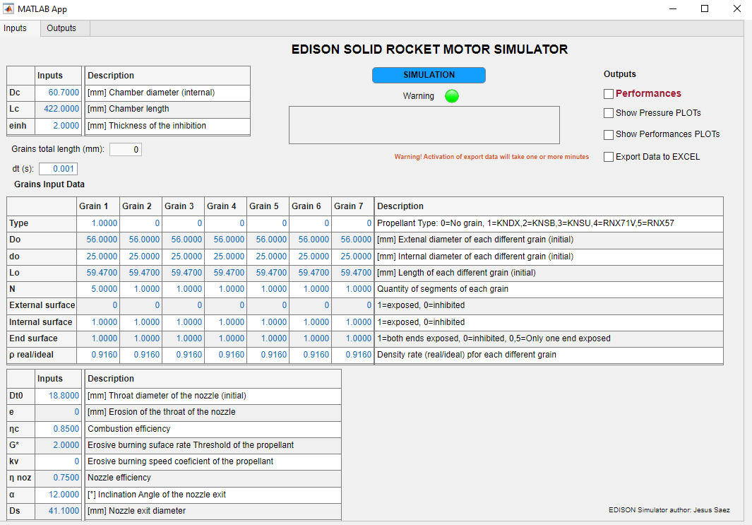
Consider that when running the executable version (.exe) it will take some time to initialize and display the graphic interface. When the interface is open every simulation will last only seconds, depending on the outputs selected.
From now on in this document it is going to be referred to the executable version (.exe).

Operation Instructions

Interface overview
The app has two tabs: input and output

Input tab
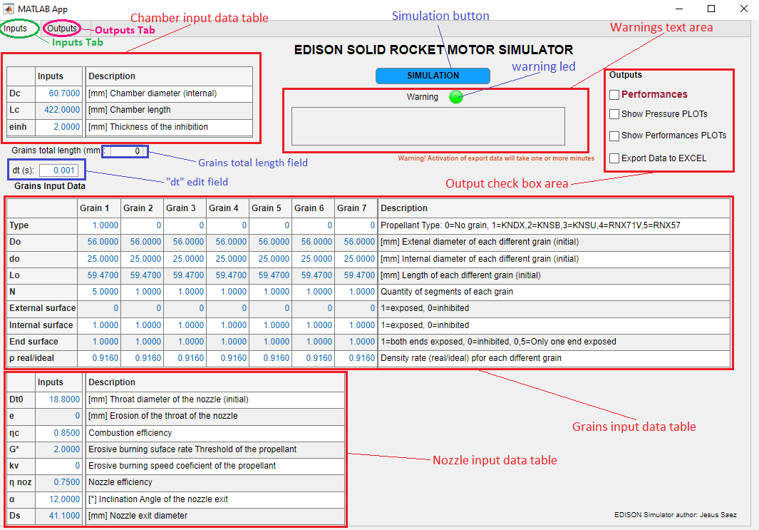

Output tab
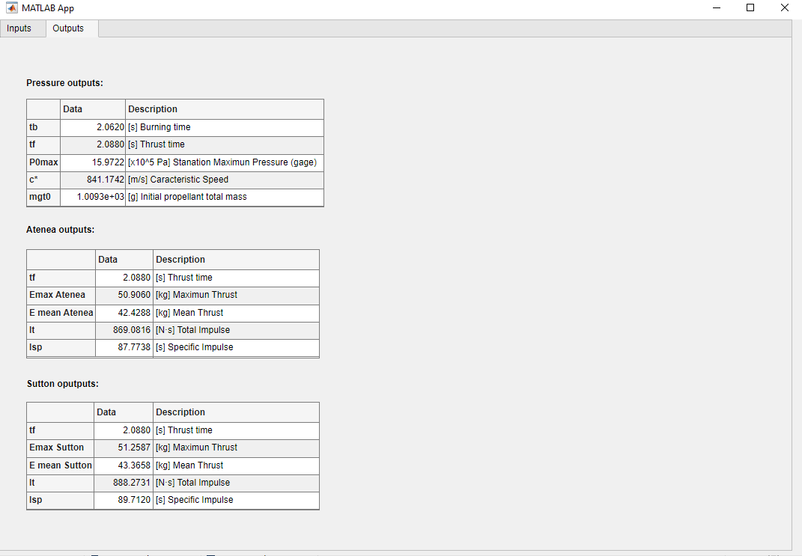
Note: ¡All the fields with data in blue colour are editable field which can be modified to input data!
By default, all the input fields are filled in. The data has to be modified with the desired motor configuration.

Tabs
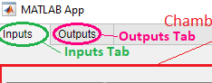
The app has two tabs:
Inputs tab: To input the data. It includes different tables and descriptive information to explain each variable and its input units.
Outputs tab: Show a summary of the results of the simulation, both pressure and performances.

Input tab

Includes:
- Chamber input data table
- Grains input data table
- Nozzle input data table
- Warning text area
- Simulation button
- Output check box area
- “dt” edit field
- Grains total length field
Below it is going to be described each part of the input tab.

Chamber input data table

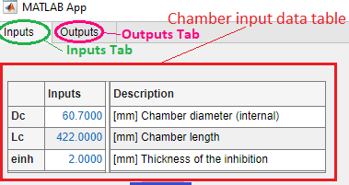
Table to input the data of the dimensions of the motor combustion chamber and the thickness of the grains inhibitor.
Units are shown in the description column.

Grains input data table

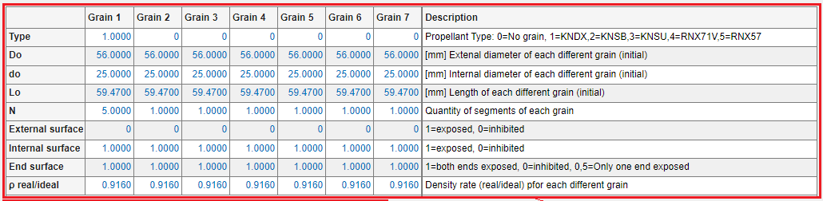
It is the table to input the data of the number and dimensions of the grains.
The grains shape is tubular. Later it is foreseen to include different grains shapes.
It is also possible to simulate cigarette grain shape by input d₀=0, external surface=0, internal surface=0 and end surface=0.5.
This table allows to input grains with different dimensions and different propellant.
Dimensions of the grains are input in the rows D₀, d₀, L₀. D₀ is the diameter of the propellant grain, i.e., it does not include the inhibition thickness.
Type of propellant of each grain is input in the “Type” row by a number whose meaning is shown in the “Description” column.
To disable a column a zero “0” has to be entered in the “Type” row.
If grains have the same dimensions and propellant type it is input in the same column entering in the “N” row the quantity of the grains.
Inhibition of the grains are defined in the rows External, Internal and End surface, being “1”=exposed surface and “0”= inhibited.
If “End surface” field input “1” both ends of the grain are exposed.
It is possible to input in the “End surface” field the value 0.5 which will simulate that only one end of the grain is exposed.
Units are shown in the description column.

Nozzle input data table

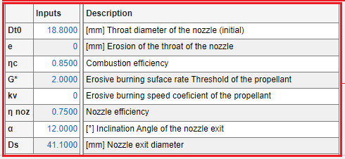
It is the table to input the data of the nozzle dimensions and other parameters.
The main parameter is Dt₀= throat diameter of the nozzle.
By now it is not possible defined the Kn₀ value instead of the Dt0. Possibly in later versions that is implemented.
There are two parameters to measure the efficiency of the combustion (η_{c}) and the nozzle (η_{noz}).
Typical values for η_{c} and η_{noz} are:
- Combustion efficiency (η_{c}): Typically, 0,95 for fine grain propellant, 0,93 coarse one. For RNX, typical value is 0,9.
- Nozzle efficiency (η_{noz}): For a well-rounded nozzle, typical values are 0,75-0,85.
Nozzle erosion (e): [mm] Increase of nozzle diameter due to its erosion. This feature is not implemented yet in the simulator.
Burning rate is defined as:
$$\boxed{r=a∙{P_{0}}^{n}·\left(1+k_{v}·G\right)}$$
$$G=G^{*}-\frac{A_{port}}{A_{g}}$$
$${Si G}^{*}-\frac{A_{port}}{A_{g}}<0→G=0$$
$$Si G^{*}-\frac{A_{port}}{A_{g}}>0→G=G^{*}-\frac{A_{port}}{A_{g}}$$
$$A_{port}= π·{\left(\frac{D_{c}}{2}\right)}^{2}-π·{\left(\frac{D-d}{2}\right)}^{2}$$
D_{c} = internal diameter of the combustion chamber
D = external (instantaneous) diameter of the grain
D = internal (instantaneous) diameter of the grain

Propellant erosive burning area ratio threshold (G*): Ratio of port to throat cross-sectional area above which no erosive burning occurs. This feature is not implemented yet in the simulator.
Erosive burning speed coefficient of the propellant (kv): Empirical constant. Zero “0” if no erosive burning expected. Typical values: 0.0-1.0. This feature is not implemented yet in the simulator.
EDISON considers a conical convergent-divergent nozzle.
a = conical convergent-divergent nozzle angle

Warning text area

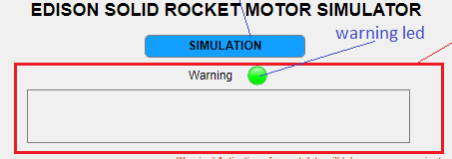
The warning text area shows messages of errors of the simulation and its cause.
When an error occurs the light of the warning led turns from green to red.
In particular, the following warning messages are displays:
If the total length of all the grains is greater than the combustion chamber length, the following error message is displayed:
“Wrong input data. Length of the grains longer than chamber one! Change input data and press SIMULATION button again”

Solving action: Change the length of the combustion chamber, number of grains or the length of the grains.
Note: In the “Grains total length field” (see next figure) is displayed the total length of the grains to help to identify the error. The value does not appear until the simulation is run, being “0” when the app is run at the beginning. If you change the length or the number of the grains, the value is not updated until the SIMULATION button is pressed.
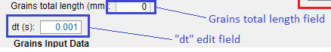
If the diameter of the grain is greater than the combustion chamber diameter, the following error message is displayed:
“Wrong input data. Chamber diameter lower than grain diameter! Change input data and press SIMULATION button again”

Solving action: Change the diameter of the combustion chamber, the diameter of the grains or the thickness of the grains inhibition.

Output check box area

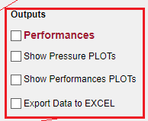
By default, the app calculates the chamber pressure, P₀(t), but it is possible to get additional outputs selecting in the “output check box area” one or more of the following options:
- Performances
- Pressure PLOTs
- Performances PLOTs
- Export Data to EXCEL

Performances
When selected “Performances” check box, the thrust vs time data is calculated by two different algorithms:
ATENEA. Simulator that calculates the fluid dynamic variables (P, T, M, v,…) in a conical convergent-divergent nozzle of a rocket engine taking as entry data the chamber pressure, P₀(t), and other values ​​such as Ds, Dg, Ta, Altitude (for the calculation of Pa), α and propellant data (T₀, Pm, γ_{two phases}).
It takes into account the conditions of the nozzle (subsonic, blocked, OCN inside the nozzle, OCO, expansion wave).
SUTTON. Simulator that calculates the performances of the motor considering the nozzle blocked with critical mass flow. It does not take into account the conditions of the nozzle (subsonic, blocked, OCN inside the nozzle, OCO, expansion wave).
By default, the combine plot showing the ATENEA and SUTTON thrust vs time is displayed.

Pressure PLOTs
When selected “Pressure PLOTs” check box, plots of different variables related to the pressure calculation, like Aburn, r, x_{web}, De, di, Lg, etc, are displayed as function of the time.
Note: This option increases just a bit the time of the simulation.

Performances PLOTs
When selected “Performances PLOTs” check box, plots of different variables, both ATENEA and SUTTON, are displayed.
Note: This option increases just a bit the time of the simulation.

Export Data to EXCEL
When selected “Export Data to EXCEL” check box, the output data are exported to the excel file “EDISON_Inputs-Outputs.xlsx”.
The data exported are several variables related to pressure and thrust calculations.
Warning: This option increases a lot the time of the simulation, so it is recommended to be used when a final solution is achieved and the results data want to be exported.
Warning: The excel file “EDISON_Inputs-Outputs.xlsx” cannot be open as an error message will come out.

Simulation button

Once the input data has been entered and the outputs selected from the “output check box area”, to run the simulation the “SIMULATION” button has to be pressed.
For the first time and when no simulation has been run the colour of the button is blue.
While the simulation is running the colour of the button turns red and when finished is turned green.
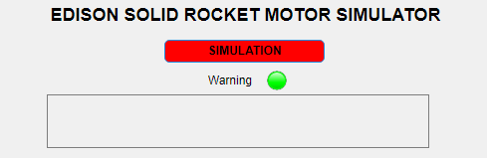
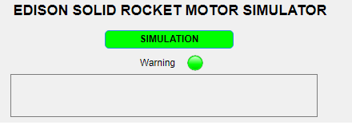
Once the simulation has finished the output data is displayed in the output tab and several plots, depending of the outputs selected in the output check box area, are shown in emerging windows.

“dt” edit field

In the “dt” edit field is possible to input the increment of the time in the simulation.
Typical value for dt is 0.001.
Lower “dt” values than 0.001 will reduce the time of running but could outcome lack of accuracy or large variation of the solution even divergency in the results.
Higher “dt” values than 0.001 will increase the accuracy of the solution but will increase the time of running.

Grains total length field

The “Grains total length” field displays total length of the grains, i.e., the sum of all the grains specified in the “grain input data” table.
The value does not appear until the simulation is run, being “0” when the app is run at the beginning.
If you change the length or the number of the grains, the value is not updated until the SIMULATION button is pressed again.

Output tab
In the output tab is displayed a summary of the most relevant results.
In the case of the performances is distinguished between ATENEA and SUTTON results.

